Exp:7-Determination and plotting of Capacitance of isolated and concentric sphere with different inner
and outer radius and dielectric constant of the dielectric mediums.
Aim:
To write program for Capacitance of an isolated sphere and two concentric sphere using SCILAB.

Software required:
•SCILAB version 6.0.1
Theory:

Program:
clc;
clear;
pi=3.14;
e=8.854*10^-12;
r1=input(&quot;Enter the r1 value is:&quot;);
r2=input(&quot;Enter the r2 value is:&quot;);
ci=4*pi*e*r2;
disp(&#39;Capacitence of isolated&#39;,[ci]);
r2=linspace(0, 10, 50);
x=ci*exp(-0.1*r2);
plot2d3(r2,x);
xlabel(&quot;raduis 2&quot;);
ylabel(&quot;capacitence&quot;);
title(&quot;isolated capcitence is&quot;);
co=(4*pi*e*(r1*r2))/(r2-r1);
disp(&#39;Capacitence of consolated&#39;,[co]);

OUTPUT :
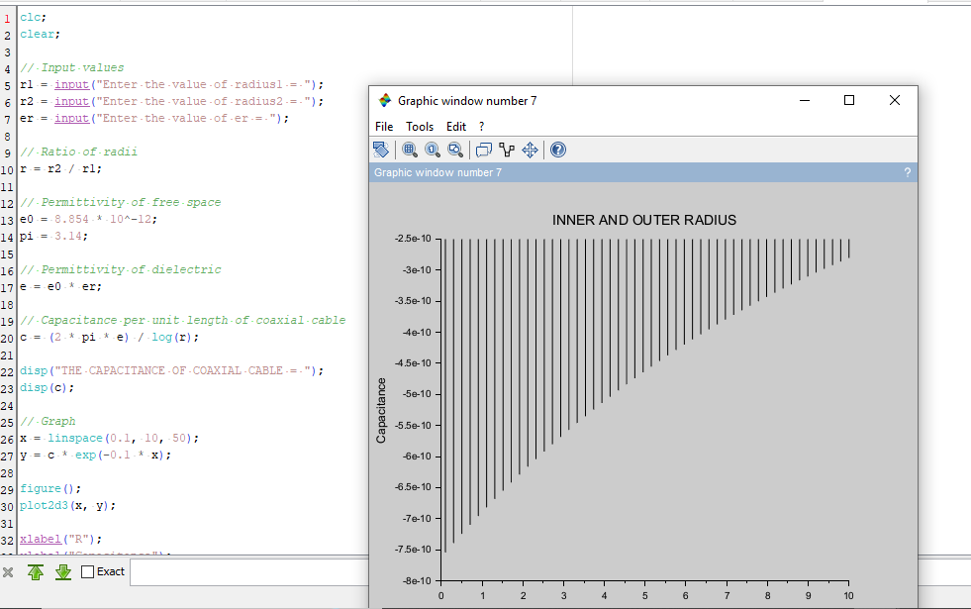
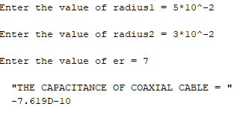
Calculations:
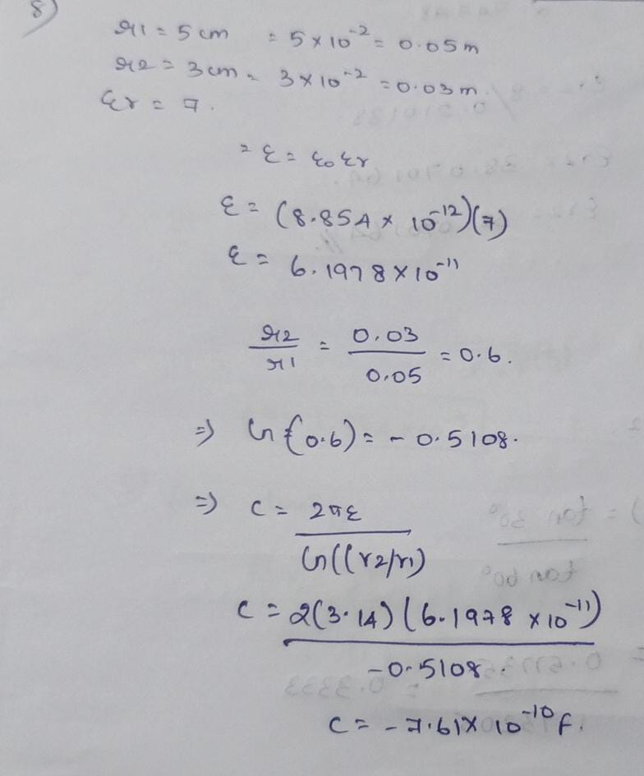
CASE 1:-CONCENTRIC SPHERICAL CAPACITOR WITH DIFFERENT DIELECTRIC MEDIUMS CODE:-
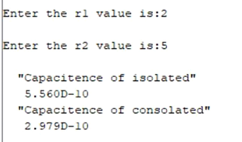
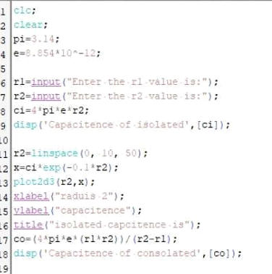
Output:
CASE 2: ISOLATED SPHERE CODE:-

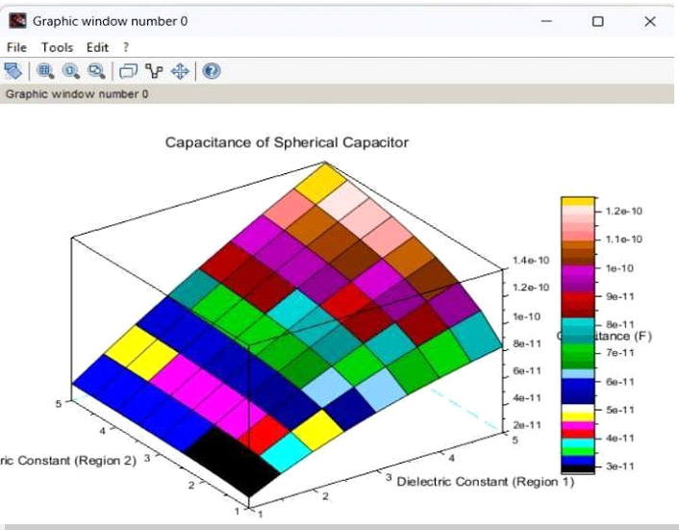
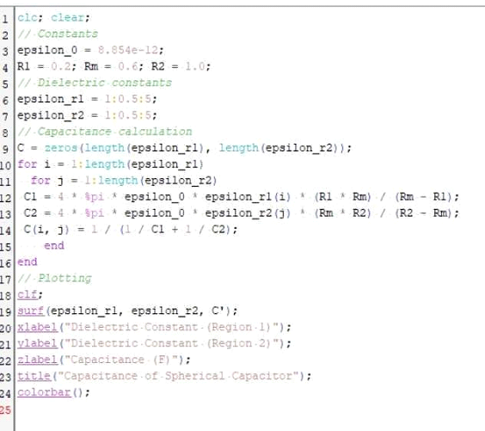
Output:

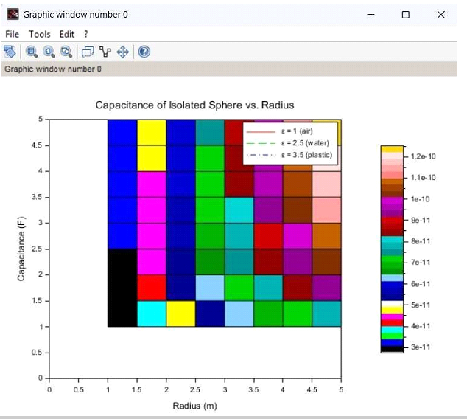
CASE 3: CONCENTRIC SPHERICAL
CAPACITOR CODE:

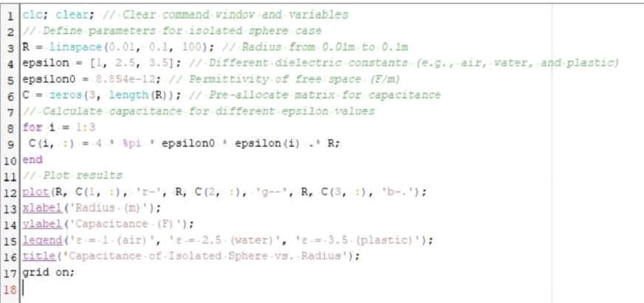
Output:

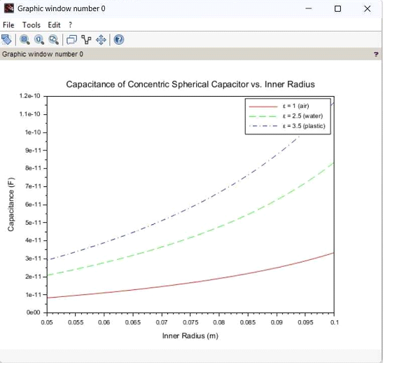
Result :
Thus the program was verified for Capacitance of an isolated sphere and two concentric sphere using SCILAB was successfully.

